Lesson Navigating Rough Waters
STUDENT MINISTRY ǀ Sunday School
Confirmation, Middle School, High School 7.5.2020
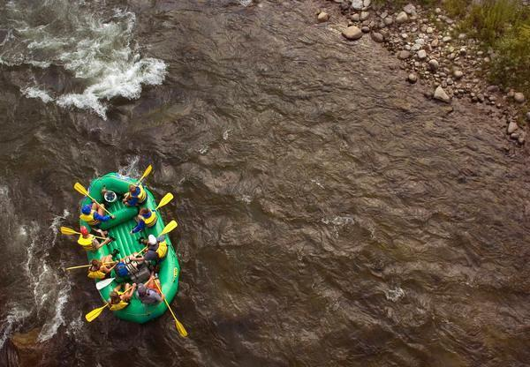
https://youtu.be/Qlewitd5XIk

Scripture reading: Psalm 32:7-8, 11
⁷ You are a hiding place for me;
you preserve me from trouble;
you surround me with shouts of deliverance.

⁸ I will instruct you and teach you in the way you should go;
I will counsel you with my eye upon you.
¹¹ Be glad in the Lord, and rejoice, O righteous,
and shout for joy, all you upright in heart!

Questions
We encourage all students to watch the video as these relate to what was taught in video.
Questions
- What circumstances in your life right now- feel like white water rapids? Be specific.
- How might you see God’s guiding voice about how to respond?
- What is God saying to you through this scripture- ⁸ I will instruct you and teach you in the way you should go; I will counsel you with my eye upon you.

Prayer for All
Almighty and most merciful God, grant that by the indwelling
of your Holy Spirit we may be enlightened and strengthened
for your service; through Jesus Christ our Lord, who lives and
reigns with you, in the unity of the Holy Spirit, one God, now
and for ever. Amen.

